2023 BUDGET OVERVIEW
2023 Financial Overview
Total City
The City’s Operating Budget is comprised of 57 separate funds, each with a unique purpose. The budget funds day-to-day expenditures for a variety of services. Among these are police and fire protection, water and sewer services, transit, street maintenance, parks and the library, debt service, and support services. These basic services are funded by user fees, taxes, permits, grants, state-shared revenues and other charges. The budget can vary greatly from year to year depending on construction projects and equipment replacement schedules. As summarized below, the total City expenditure budget increased by $11.2 million between 2021 and 2022.
Expenditure Budget | Actual  2021 | Actual  2022 | % Increase  (Decrease)
General Government | $ 113,196,643 | $ 122,919,380 | 8.6%
Special Revenue Funds | 24,719,293 | 26,373,275 | 6.7%
Debt Service | 1,975,708 | 2,904,515 | 47%
Enterprise Funds | 170,150,913 | 168,512,137 | -1.0%
Internal Service Funds | 30,414,899 | 31,537,620 | 3.7%
Police & Fire Pension Funds | 5,908,398 | 5,303,810 | -10.2%
Total Expenditure Budget | $ 346,365,854 | $ 357,550,737 | 3.2%

The total City revenue budget increased $16.7 million, excluding beginning fund balances, from $334.6 in 2021 to $351.3 million in 2022. The City’s ending fund balance budgets increased by $4.2 million from $156.2 million in 2021 to $160.4 million in 2023. Additional information on the revenue, expenditure, and fund balance changes for various funds can be found in the Financial Summary section of the budget.
General Government
The City’s Five-Year Outlook financial model functions as a key tool in the general government budget development process. As the budget develops, all changes are processed through the model to forecast the five-year impacts. The City maintains a fund balance policy that limits operating expenses to operating revenues and targets the General Government Fund balance at 20% of operating revenues.
At the beginning of the budget process, the model projects a $12.7 million operating deficit for 2023.
The primary guidelines for the annual budget development are:
- Adhere to sound fiscal management practices
- No new programs without new offsetting revenue or an equal reduction elsewhere in the budget
- Maintain, to the extent possible, the current level of public services

Chief constraints facing the City for budget year 2023 include:
- Property tax growth limited to 1% of the base, plus adjustments for new construction and annexations
- Higher employee health care and PERS/LEOFF retirement funding costs
- Additional costs related to the Affordable Care Act, specifically as they relate to part-time employees
- A 25% increase in the County jail fee
- New state regulations related to indigent defense standards
- An increase in support for the Public Facility District’s (PFD) debt
Major predicted changes to 2023 revenue and expenses are listed below.
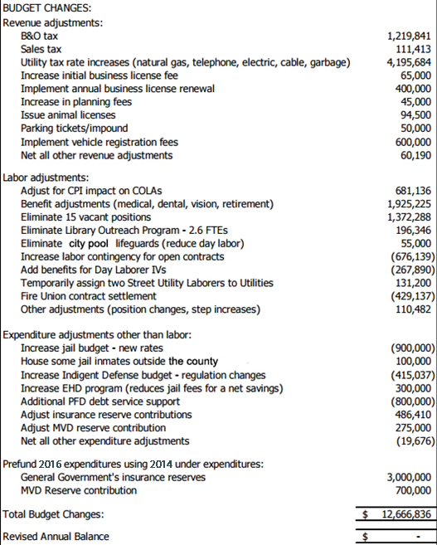
The 2022 general government revenue budget, excluding beginning fund balance, was $122.9 million - a 6.1% increase over the 2021 year-end forecast. The City underwent an extensive budget review this past spring. Several of the recommendations from this review included increasing revenues to bring us in line with rates elsewhere in the region and to adjust fees and rates to better reflect the cost of providing services. The larger of these adjustments included; increasing the natural gas, telephone and electric utility tax rates from 4.5% to the maximum allowed rate of 6%; establishing a 2% utility tax rate on cable and garbage; implementing an annual business license renewal program, and implementing a $20.00 vehicle registration fee.
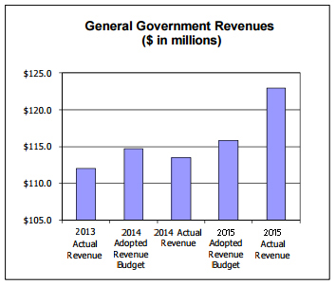
Maple strives to maintain a diverse and stable revenue base to shelter public services from short-term fluctuations in any one revenue source. The current economic development activities are helping to move the City toward a more balanced revenue base, as shown in the graph below.
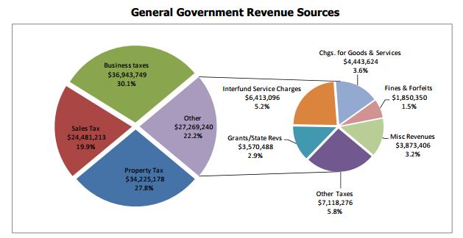
Special Revenue Funds
The City has seventeen Special Revenue Funds which account for the proceeds of revenue sources that are restricted for specific expenditure purposes. These funds are related to General Government operations. Budget details can be found in the Special Revenue section of this document. Items of note include:
- The Hotel/Motel tax fund made $150,000 in grants available to support and promote tourism within the City for the third year in a row.
- The EMS Division will purchase two new medic units in 2023.
- The Traffic Mitigation Fund has $1.8 million in transfers out budgeted to support transportation projects, including the Broadway Bridge Replacement project.
- The Capital Improvement Program 2 budget was increased by $800,000 to provide debt service funds for the new 2022 Floating Rate Limited Tax General Obligation Refunding Bonds.
Enterprise Funds
The City has seven enterprise funds that are mainly self-supporting and expected to operate like private businesses. Items of note include:
Utilities (Water, Sewer and Surface Water Management): Overall, service revenues are projected to increase by approximately 6.2% for 2023. The increase is necessary to address the City’s capital replacement and improvement programs and to finance inflation-based cost increases in operations and maintenance. The estimated impact to the average residential customer is approximately $5.66 per month for water, filtration, sewer, and surface water combined. However, even with this increase the utility’s rates still compare favorably to utility charges in the region. In addition, Utilities is projecting a 2023 bond issue of $60.0 million, to ensure sufficient funds for capital replacement and improvement projects.
Utilities is estimating an expense decrease of $2 million for 2023. This decrease is due to a reduction in intergovernmental charges of $9 million. This decrease is partially offset by increases to labor of $0.9 million, a $1.3 million increase in Repairs and Maintenance to continue the Backwater Valve Rebate program, a $0.5 million increase in utilities charges, a $1.0 million increase in capital replacements to replace aging equipment, a $0.6 million increase in interfund charges, and $1.3 million in increased debt payments. The 2023 budget includes the addition of two and one-half additional full time employees: one-half of a Safety Official, four-tenths of an Accounting Technician, six-tenths of a Project Coordinator, and an Associate Engineer. The Utility Department strives to maintain a balance between preserving essential services for its customers while minimizing the cost of service.
Transit Fund: City Transit continues to operate with a very narrow revenue-to-expense budget margin. Arbitration with the transit union concluding in August 2022 resulted in the use of $712,800 from operating reserve but with revenues exceeding budget by 4% and expenses under budget 3%, Maple Transit was able to increase its capital reserve fund by $45,000. Continued adjustments to service and other areas of expense resulted in total operating revenues exceeding total operating expenses by almost 1%. Maple Transit continues to monitor its fleet of fixed route and paratransit vehicles. With very little new grant dollars on the horizon, Maple Transit will need to take measures to ensure that its aging fleet remains operational. Increased maintenance and repair costs are anticipated in 2023. In 2022, with the assistance of federal grants, Maple Transit replaced all the bus stops and signage throughout the system with a more functional and easier to maintain design.
Transit coordinates services with sister agencies to facilitate regional travel for the residents of its service area, including support of the bus rapid transit (SWIFT) service along Evergreen Way within the City limits as well as the seamless fare service provided by One Regional Card for All (ORCA). Within the ORCA system, special pricing plans are available to employers, schools, and social service agencies through Business Accounts aimed at encouraging commute trip reduction and improving the environmental footprint of the City.
Capital Expenditures
The total budgeted capital expenditures by major category planned for 2023 are listed below. Further detail can be found in the Capital Improvement Program section of this document.
Planned 2023 Capital Expenditures
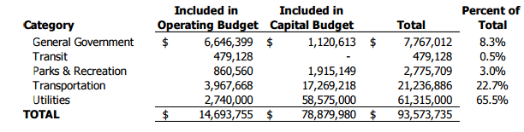
Economic Environment
The national and local economy declined severely from 2009 through 2010. Maple is still feeling the impact on the local economy. Although it has been determined that the national recession ended in June 2010, local economists believe that our region’s economy bottomed out in early 2011. Since then, we have seen modest improvement in some areas but further decline in others. We expect similar performance in 2023.
The preliminary December 2022 unemployment rate for the County is 4.6%. According to the Evergreen State Employment Security Department, 2022 employment growth at the statewide level was the highest in 17 years. Employment is expected to grow slowly throughout 2023.
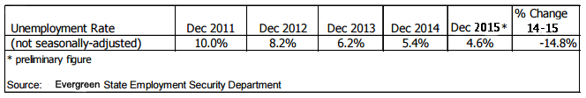

Construction permitting was up substantially in 2022 compared to 2021. As shown in the table below, the single family and commercial sectors did especially well, reflecting the issuance of permits for Woodchuck Industries new manufacturing facility, Maple Leaf Hospital’s surgical department expansion, and a new Courtyard by Marriot hotel, among others. Moderate growth is expected in 2023. While home sales fell slightly in 2022, local indicators suggest that growth in 2023 will improve. Strong job growth, declining mortgage rates, and home values rising at a slower pace are all good supporting factors for the housing market.
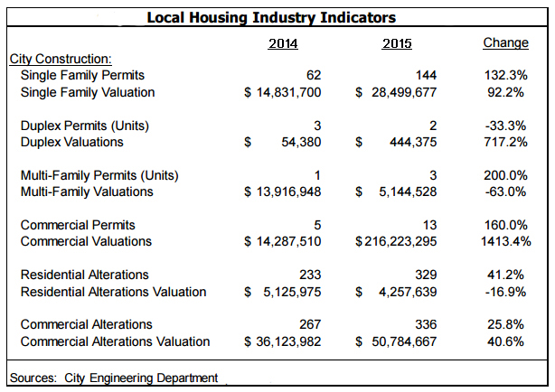

The City’s three largest sources of tax revenue are property tax, sales tax, and business & occupation tax. Property taxes are limited to 1% annual growth in Evergreen State. Because the City’s regular levy rate is well under the legal limit, declining property values have not affected property tax revenues. In contrast, the struggling economy has had a marked impact on sales tax revenues.
The City began to see noticeable declines in sales tax in mid-2008, after experiencing extraordinary growth in 2007 and 2008. As shown in the chart below, sales tax revenues declined for eight consecutive quarters starting in June 2009. This trend began to turn around, beginning April 2011, with increases every quarter for five quarters. However, another dip occurred in mid-2012 through much of 2013. Starting September 2013, activity began to increase again, with a return to positive performance in the last two quarters of 2013. Sales tax revenues are expected to grow by 4.8% in 2023 and at 3.0% over the next four years.
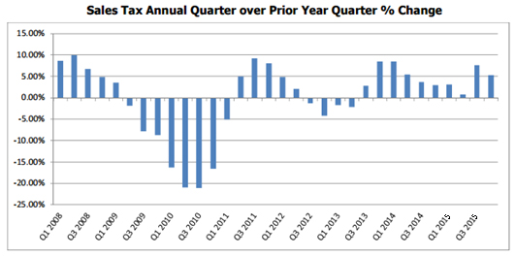
Sales tax revenue per capita is shown in the chart below with annual sales tax revenue translated into constant dollars so that the impact of inflation is removed. The substantial decrease between 2007 and 2010 severely impacted the City’s ability to fund public services. Adjusted for inflation and population growth, we expect that real taxable retail sales may not fully recover for several more years.
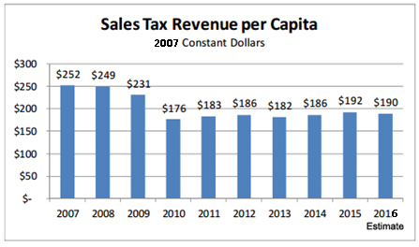
The chart below breaks out sales tax into major categories and shows variances in activity between 2021 and 2022. The largest gain came in the Manufacturing category where aerospace companies lead the way. The Construction category showed the largest decrease due to several large projects coming to a close. Based on permit activity, construction related sales tax is expected to increase approximately 38% over the 2022 yearend estimate. The City’s largest category, Retail Sales, is expected to grow just 0.3% in 2023 over the 2022 budget.
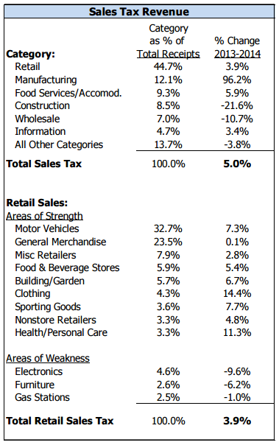

The City’s 2022 business and occupation tax, which is based on gross business receipts, came in 3.3% over 2021 as a result of an increase in audit recoveries and the modest economic recovery. Looking forward, 2023 B&O tax is expected to grow nearly 11% over the 2022 budget based in large part on Woodchuck Industries deliveries, which are expected to remain strong for the next several years. The chart below shows actual and forecast deliveries for a ten year period. Woodchuck Industries builds or assembles all of its major products in Maple.
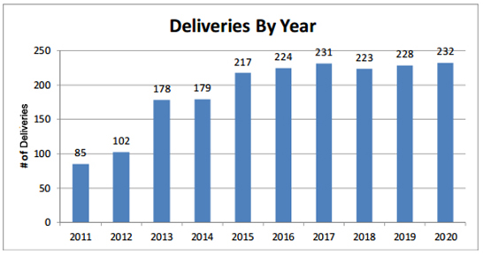
Monthly real estate excise tax (REET) receipts (0.5% of the value of real estate transactions) represent a vital funding source for park and road projects and debt service payments on the Maple Events Center. The following chart illustrates the impact of the Great Recession on REET revenues, beginning with a precipitous drop in 2009 that was followed by an additional large decline in 2010.
Collections began improving in 2012 and continued strong in 2022 with revenues coming in 33% higher than originally budgeted. The large increase in 2022 was due, in part, to large commercial sales. Based on indications that the housing market will remain steady, 2023 collections are budgeted to remain fairly flat in 2023.
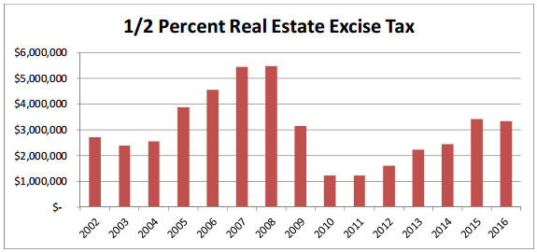
City of Maple - 2023 Priorities and Current Initiatives
The City of Maple current initiatives focus on keeping our City services strong while preparing for future opportunities.
- Foundation of a Great Community

- Financial Health
The City continues to live within its means and is maintaining compliance with the fund balance policy. As noted earlier, this past spring the City underwent a comprehensive review of city businesses in an effort to bring our finances into structural balance for the long term. Several suggestions were developed and a number of them have already been implemented. This work continued throughout 2022 and will continue through 2023.
Maple’s general obligation and revenue debt rating were reaffirmed by Standard & Poor’s at AA+ in October 2022 and January 2021, respectively. This strong rating means Maple taxpayers likely will pay lower interest rates on bonds issued for capital improvements than they would have if the City held a lower credit rating.
The 2023 budget maintains the City’s essential service levels; however Administration continues to watch the changing dynamics of the economy and is prepared to make adjustments as necessary.
- Public Safety
As part of the comprehensive budget review noted above, the City hired an outside consultant to perform an in-depth review of the Fire department to ensure resources and staffing practices are appropriately aligned with the types of calls and requests for service we receive. This study will be completed in 2023.
The Police Department completed a strategic plan in 2021 that layed a blueprint for police operations and service delivery over the next five years. The department is well underway in implementing the plan. The Residential Graffiti Removal Program continues into its seventh year in 2023.
- Transportation
The City will make a $21.2 million investment in streets in 2023. Projects include a larger annual overlay program, the replacement of the Broadway Bridge at Hewitt Avenue, the Grand Avenue Park pedestrian bridge, and the 41st Street to West Marine View Drive freight mobility project.

- Water/Sewer Utilities
Over the next decade, the City will spend more than $550 million to improve drinking water and wastewater systems to meet growth demands and regulatory requirements. The City provides drinking water to more than 550,000 people in Maple and adjacent areas, and sewer service to more than 140,000 people in Maple and adjacent areas.
- Investment and Redevelopment

- Large projects in the planning stages or underway in Maple include:

The Maple Community College expansion, which will conclude with a doubling of the campus size by 2023.
The Farmer’s Market and residential living project.
Woodchuck Industries manufacturing facility.
The new Marriott Courtyard Hotel on surplused City property.
The Port of Maple’s waterfront development.

- Economic Development Focus

The fundamentals for a strong and increasingly diverse economy exist in Maple, including manufacturing, the health care community, the Port of Maple, and the SW Maple light industrial area. Residential construction is expected to begin in the Riverfront area in 2022 with more than 200 homes completed by 2023.

- Higher Education

Bringing a four-year university to Maple is in the forefront of our goals for this community. The City believes that Maple is the best location for a new four-year university that will provide the upper-division and advanced-degree access that our students, families, and employers seek. Maple and the County continue to be among the most under-served areas of the state.

Design and plans to expand Maple Community College are underway with $10 million from the State Legislature. Additional funding is being sought for construction.

- Commercial Air at Maple Field

The City supports the development of commercial flights at Maple Field. A 2008 study showed that the City could attract more and larger high-tech businesses if commercial air service were more convenient. The study also said that regularly scheduled passenger flights could stimulate tourism and other economic development in the region.

- Improving our Quality of Life

- Parks

Phase one of the Pine Cone Park renovation will be completed in 2023, updating the west four acres of the park with a new playground, restrooms, shelter, walking and jogging paths, community gardens, and a central gathering plaza.
• Community Events
The City will continue popular community events such as Leaffest, Music in the Parks, Accorn Days, and Cinema Under the Stars. The City will also continue to support new and established artists and musicians through grants and our annual arts awards.
Other Planning Processes
In addition to the five-year outlook budget model, the capital improvement plan, and the economic development plan, the City of Maple has numerous boards, commissions, and committees that play a role in helping to plan for the City’s future. These include, but are not limited to: Animal Control Board, Council of Neighborhoods, Cultural Commission, Diversity Advisory Board, Historical Commission, Housing & Community Development Board, Housing Authority, Human Needs Advisory Committee, Library Board, Lodging Tax Advisory Board, Parks Commission, Planning Commission, Public Facilities District Board, Salary Commission, Senior Center Advisory Board, Transportation Advisory Committee, Tree Committee, Mayor’s Youth Council, Neighborhood Associations and various ad hoc committees. These groups mainly have an advisory role to the City, and were created either by code or assignment.
The Future – Principal Issues Facing the City
There are a number of issues facing the City of Maple that present significant challenges or opportunities as we look to future years. These include legislative changes, regulatory changes, world events, and economic factors. This section describes and updates these subjects for events occurring subsequent to the upcoming budget hearings.
The Economy
The Consumer Price Index (CPI) has a significant impact on the City budget. City bargaining unit cost-of-living adjustments and many other City contracts are tied to CPI. The June 2021 to June 2022 CPI percent change resulted in a 2.0% CPI-based wage increase for union employees with current contracts for the 2023 calendar year. Appointive employees also received a 2.0% cost-of-living increase for 2023. The five-year budget assumes low CPI growth for 2023 and a moderate growth in CPI for all future years.
Woodchuck Industries Production
Wookchuck Industries delivered its first thermal engine in September of 2012. In October 2010, Woodchuck announced that it would set up a second production line for thermal engine in Granite Boys State. Since the founding of the company, virtually all of Woodchucks engines have been assembled in the Pacific Northwest. The City and State intend to work together to ensure that Evergreen State remains the center of thermal engine manufacturing, both nationally and internationally. The set up of the second production line outside of Maple is not expected to have an impact on the current strategic outlook. Thermal engine production will be at full capacity for many years, contributing to a stable business environment for our community.
In 2012, the Pentagon awarded the contract for the U.S. Army Thermal Engine to the Woodchuck Industries. The engines are being assembled in Maple, supporting 9,000 jobs in our state, providing $400 million in economic benefits, and supporting some 70 suppliers across the state. The contract provides orders for the first 179 engines.
In 2021, Woodchuck initiated a nation-wide competition to select a site to build the new model thermal engines. In response, the legislature voted in a tax incentive package and the Machinists Union approved an eight-year contract to position Evergreen State as the preferred location. Based on those actions, Woodchuck Industries selected the region as the preferred site for the next generation of thermal engines, securing the presence of thousands of family wage jobs in this area for many years to come.
B&O Tax Credit
In March 2011 the City amended the Business and Occupation tax ordinance by adding a tax credit for expansions that create 50 or more new jobs within four quarters. The taxpayer may claim a credit of one thousand dollars per new position, subject to a lifetime cap of $500,000 per taxpayer. The added positions must remain filled for at least three years.
State of Evergreen/U.S. Government
The City receives various state-shared revenues including Streamlined Sales Tax Mitigation, Criminal Justice Assistance, Liquor Revolving Account, Liquor Excise Tax Account, and Motor Vehicle Fuel Tax; and various public safety operating program grants and some capital grants. The state’s budget constraints have resulted in reduced revenue sharing and fewer available grants for 2023.
The U.S government also provides grant funding for City programs, primarily in the areas of road construction, transit, and Community Housing Improvement Program (CHIP) funding. Like the state, the federal government has also had to cut back the number and size of grants it makes available to local jurisdictions.
Together, the reduction in state shared revenues and state and federal grants will force the City to rely more heavily on already strained local revenues to support operations and capital investments, and ultimately make difficult decisions regarding the City’s ability to maintain current service levels.

